LAB 02 REPORT
GROUP MEMBERS: BURAIR HAIDAR 09628
SUALEH ABBAS 10303
task 0:
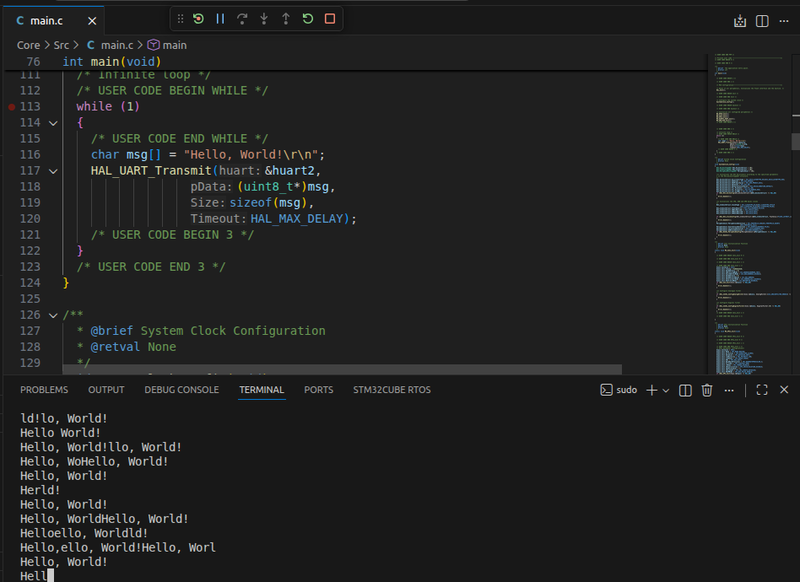

Task 1:
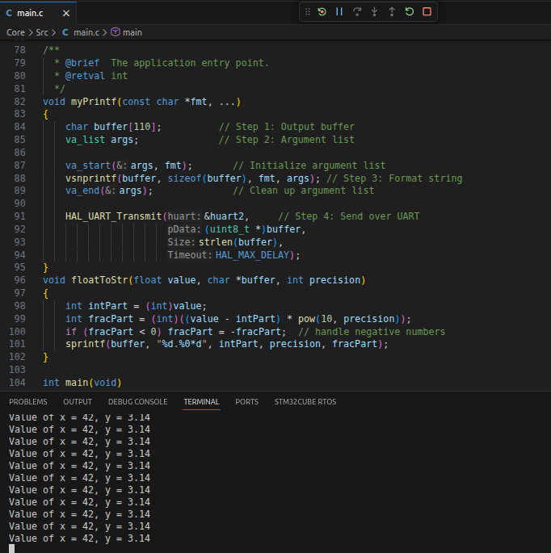
code & output

While Loop:

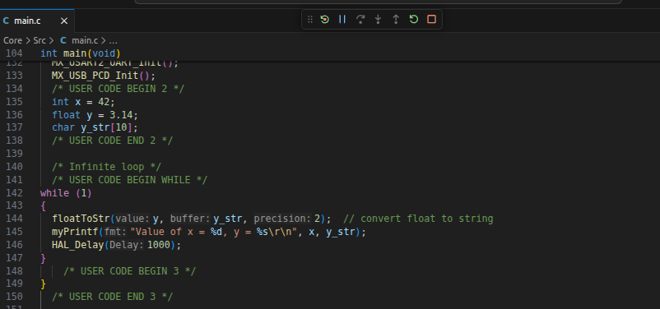

TASK 2:
code & output
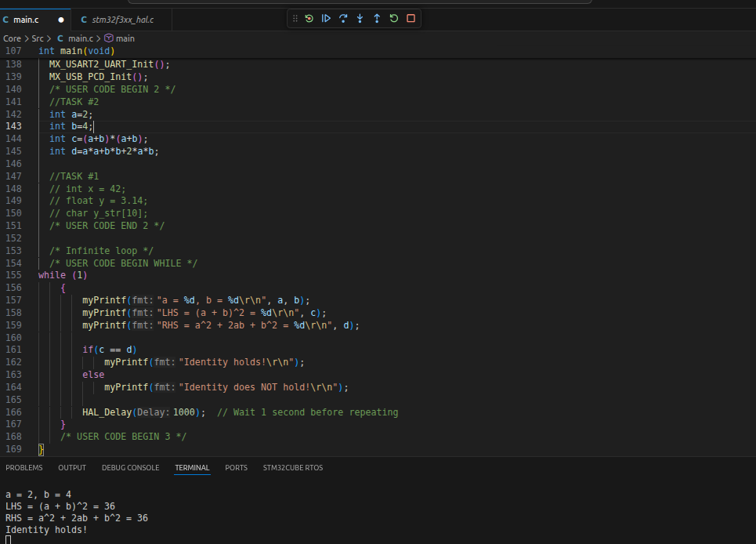

TASK #3

code:

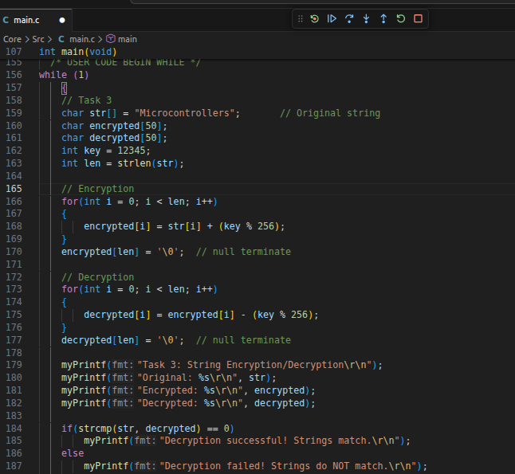
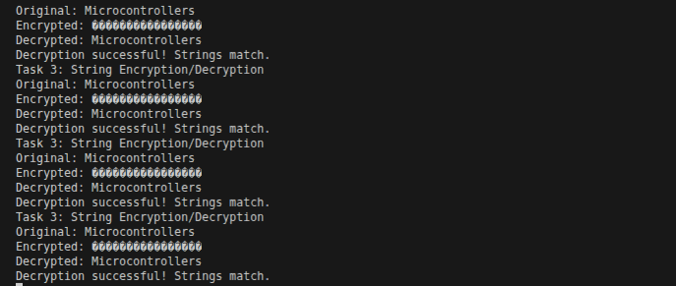
output:

TASK #4
code:

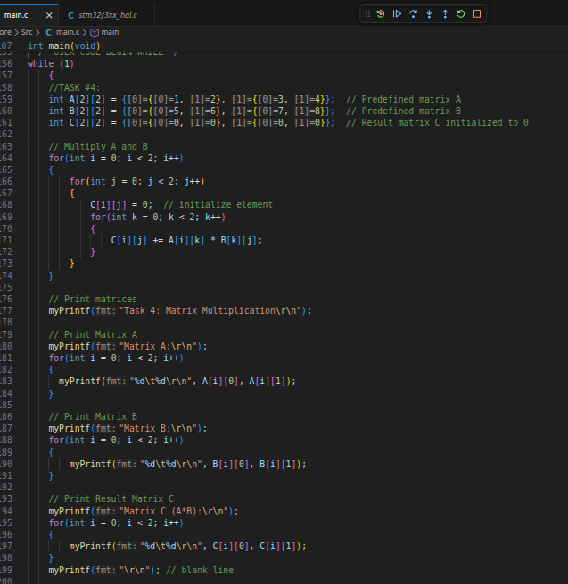
OUTPUT:

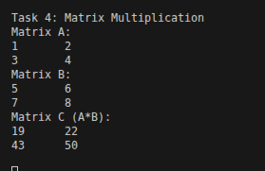

TASK #5:
code:
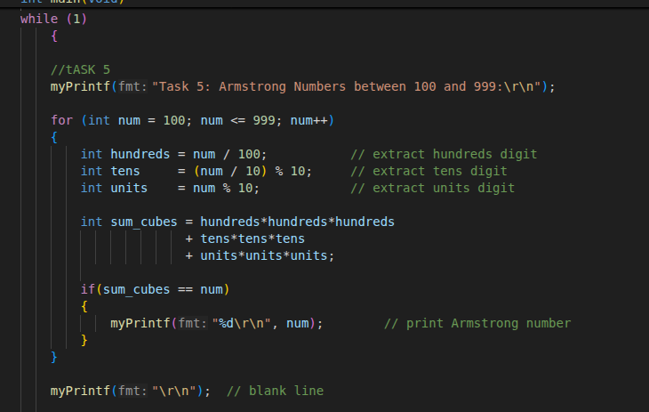
Output:

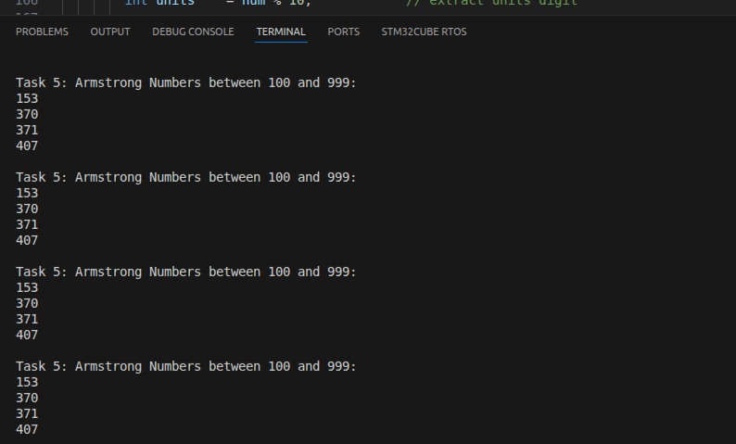

Evaluation Question:
Explain the role of USART2 in UART communication on the STM32F3 Discovery board. Why must TX and RX lines be crossed when connecting to an external USB-UART module?

USART2 on the STM32F3 board provides the hardware interface for UART communication by handling data transmission and reception, including baud rate, and status control, and is commonly used for communication with a PC or external devices via PA2 (TX) and PA3 (RX).
When connecting to an external USB-UART module, the TX and RX lines must be crossed because the transmitter of one device must connect to the receiver of the other (STM32 TX → USB-UART RX and STM32 RX → USB-UART TX); otherwise, both devices would transmit and listen on the same lines, preventing communication.

